**Lab 6 – Arithmetic Unit**

CS1050 Computer Organization and Digital Design

Name : **Dissanayake D.M.A.K.**

Index No. : **220135N**

Group : **44**

# Lab Task:

***Designing and Development of 4-bit register and 4-bit Arithmetic Unit run on Basys3 board.***

**Introduction**

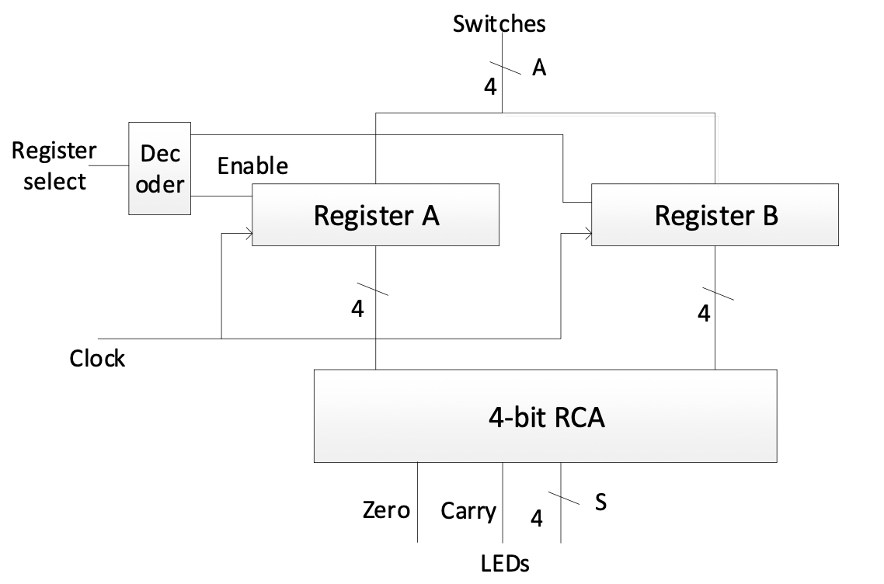 In the realm of microprocessors, registers play a pivotal role as repositories for sets of bits. Our mission in this lab is to engineer a 4-bit Arithmetic Unit capable of performing additions on numbers housed in two separate registers. To grasp the intricacies of this task, we'll begin with the creation of a 4-bit register utilizing D Flip Flops. This register, featuring an Enable input and a Clock input, will set the stage for the subsequent integration with our 4-bit RCA.

**1)4-bit Register**

**Design Source File**

----------------------------------------------------------------------------------

-- Company:

-- Engineer:

--

-- Create Date: 03/12/2024 02:07:04 PM

-- Design Name:

-- Module Name: Reg - Behavioral

-- Project Name:

-- Target Devices:

-- Tool Versions:

-- Description:

--

-- Dependencies:

--

-- Revision:

-- Revision 0.01 - File Created

-- Additional Comments:

--

----------------------------------------------------------------------------------

**library** IEEE**;**

**use** IEEE**.**STD_LOGIC_1164**.ALL;**

-- Uncomment the following library declaration if using

-- arithmetic functions with Signed or Unsigned values

--use IEEE.NUMERIC_STD.ALL;

-- Uncomment the following library declaration if instantiating

-- any Xilinx leaf cells in this code.

--library UNISIM;

--use UNISIM.VComponents.all;

**entity** Reg **is**

**Port** **(** D **:** **in** STD_LOGIC_VECTOR **(**3 **downto** 0**);**

En **:** **in** STD_LOGIC**;**

Clk **:** **in** STD_LOGIC**;**

Q **:** **out** STD_LOGIC_VECTOR **(**3 **downto** 0**));**

**end** Reg**;**

**architecture** Behavioral **of** Reg **is**

**begin**

**process** **(**Clk**)** **begin**

**if** **(rising_edge(**Clk**))** **then**

**if** En **=** '1' **then**

Q **<=** D**;**

**end** **if;**

**end** **if;**

**end** **process;**

**end** Behavioral**;**

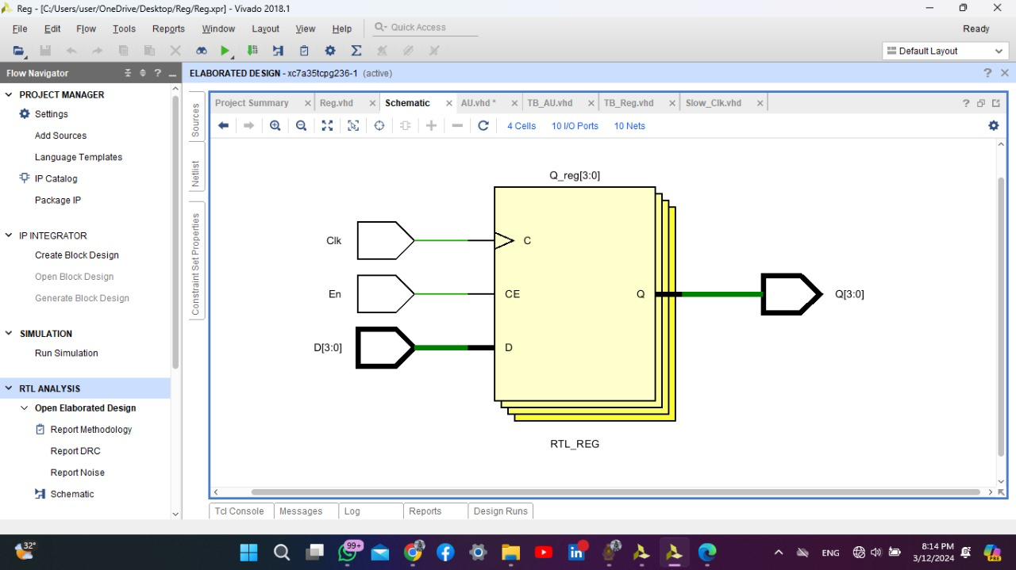**Elaborated design schematic**

**2)4-bit Arithmetic Unit**

**Design Source File**

----------------------------------------------------------------------------------

-- Company:

-- Engineer:

--

-- Create Date: 03/12/2024 02:11:40 PM

-- Design Name:

-- Module Name: AU - Behavioral

-- Project Name:

-- Target Devices:

-- Tool Versions:

-- Description:

--

-- Dependencies:

--

-- Revision:

-- Revision 0.01 - File Created

-- Additional Comments:

--

----------------------------------------------------------------------------------

**library** IEEE**;**

**use** IEEE**.**STD_LOGIC_1164**.ALL;**

-- Uncomment the following library declaration if using

-- arithmetic functions with Signed or Unsigned values

--use IEEE.NUMERIC_STD.ALL;

-- Uncomment the following library declaration if instantiating

-- any Xilinx leaf cells in this code.

--library UNISIM;

--use UNISIM.VComponents.all;

**entity** AU **is**

**Port** **(** A **:** **in** STD_LOGIC_VECTOR **(**3 **downto** 0**);**

RegSel **:** **in** STD_LOGIC**;**

Clk **:** **in** STD_LOGIC**;**

S **:** **out** STD_LOGIC_VECTOR **(**3 **downto** 0**);**

Zero **:** **out** STD_LOGIC**;**

Carry **:** **out** STD_LOGIC**);**

**end** AU**;**

**architecture** Behavioral **of** AU **is**

**component** Reg

**Port** **(** D **:** **in** STD_LOGIC_VECTOR **(**3 **downto** 0**);**

En **:** **in** STD_LOGIC**;**

Clk **:** **in** STD_LOGIC**;**

Q **:** **out** STD_LOGIC_VECTOR **(**3 **downto** 0**));**

**end** **component;**

**component** RCA_4

**Port** **(** A0 **:** **in** STD_LOGIC**;**

A1 **:** **in** STD_LOGIC**;**

A2 **:** **in** STD_LOGIC**;**

A3 **:** **in** STD_LOGIC**;**

B0 **:** **in** STD_LOGIC**;**

B1 **:** **in** STD_LOGIC**;**

B2 **:** **in** STD_LOGIC**;**

B3 **:** **in** STD_LOGIC**;**

C_in **:** **in** STD_LOGIC**;**

S0 **:** **out** STD_LOGIC**;**

S1 **:** **out** STD_LOGIC**;**

S2 **:** **out** STD_LOGIC**;**

S3 **:** **out** STD_LOGIC**;**

C_out **:** **out** STD_LOGIC**);**

**end** **component;**

**component** Slow_Clk

**Port** **(** Clk_in **:** **in** STD_LOGIC**;**

Clk_out **:** **out** STD_LOGIC**);**

**end** **component;**

**signal** Enable_A **:** STD_LOGIC**;**

**signal** Enable_B **:** STD_LOGIC**;**

**signal** A_out **:** STD_LOGIC_VECTOR **(**3 **downto** 0**);**

**signal** B_out **:** STD_LOGIC_VECTOR **(**3 **downto** 0**);**

**signal** Clk_Slow **:** STD_LOGIC**;**

**begin**

--Logic of 1 to 2 decoder

Enable_A **<=** **not** RegSel**;**

Enable_B **<=** RegSel**;**

SLow_Clk_0 **:** Slow_Clk

**port** **MAP** **(**Clk**,** Clk_Slow**);**

Reg_A **:** Reg

**port** **MAP** **(**

A**,**Enable_A**,**Clk_Slow**,**A_out

**);**

Reg_B **:** Reg

**port** **MAP** **(**

A**,**Enable_B**,**Clk_SLow**,**B_out

**);**

RCA_4_0 **:** RCA_4

**port** **MAP** **(**

A0 **=>** A_out**(**0**),**

A1 **=>** A_out**(**1**),**

A2 **=>** A_out**(**2**),**

A3 **=>** A_out**(**3**),**

B0 **=>** B_out**(**0**),**

B1 **=>** B_out**(**1**),**

B2 **=>** B_out**(**2**),**

B3 **=>** B_out**(**3**),**

C_in **=>** '0'**,**

s0 **=>** S**(**0**),**

s1 **=>** S**(**1**),**

s2 **=>** S**(**2**),**

s3 **=>** S**(**3**),**

C_out **=>** Carry

**);**

--logic for zero

Zero **<=** **(**A_out**(**3**)** **xnor** B_out**(**3**))** **and** **(**A_out**(**2**)** **xnor** B_out**(**2**))** **and** **(**A_out**(**1**)** **xnor** B_out**(**1**))** **and** **(**A_out**(**0**)** **xnor** B_out**(**0**));**

**end** Behavioral**;**

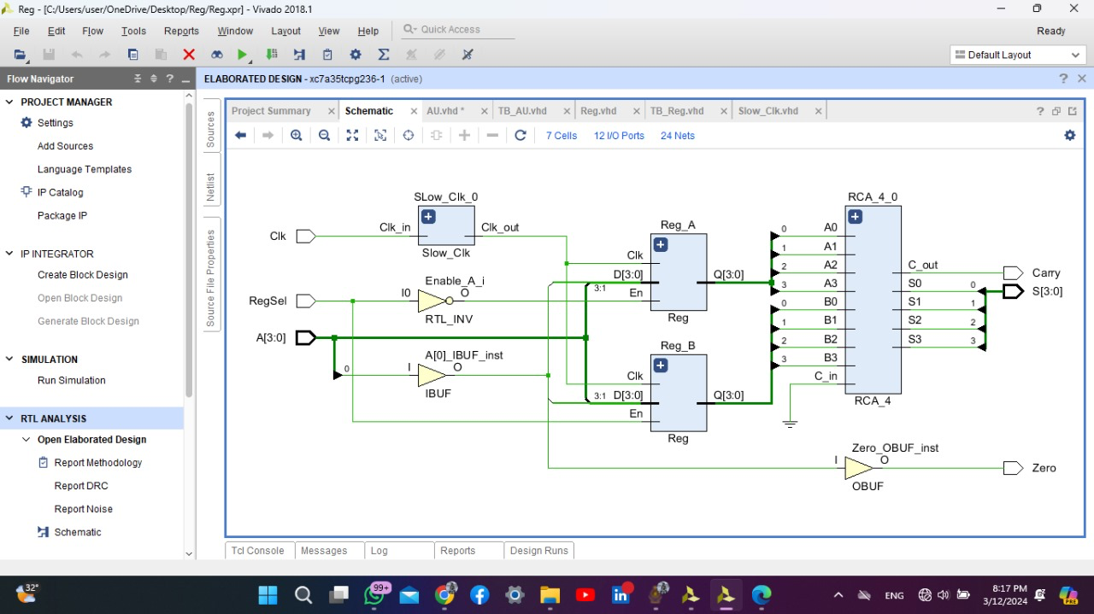**Elaborated design schematic**

**Simulation source file**

----------------------------------------------------------------------------------

-- Company:

-- Engineer:

--

-- Create Date: 03/12/2024 03:47:22 PM

-- Design Name:

-- Module Name: TB_AU - Behavioral

-- Project Name:

-- Target Devices:

-- Tool Versions:

-- Description:

--

-- Dependencies:

--

-- Revision:

-- Revision 0.01 - File Created

-- Additional Comments:

--

----------------------------------------------------------------------------------

**library** IEEE**;**

**use** IEEE**.**STD_LOGIC_1164**.ALL;**

-- Uncomment the following library declaration if using

-- arithmetic functions with Signed or Unsigned values

--use IEEE.NUMERIC_STD.ALL;

-- Uncomment the following library declaration if instantiating

-- any Xilinx leaf cells in this code.

--library UNISIM;

--use UNISIM.VComponents.all;

**entity** TB_AU **is**

-- Port ( );

**end** TB_AU**;**

**architecture** Behavioral **of** TB_AU **is**

**component** AU

**Port** **(** A **:** **in** STD_LOGIC_VECTOR **(**3 **downto** 0**);**

RegSel **:** **in** STD_LOGIC**;**

Clk **:** **in** STD_LOGIC**;**

S **:** **out** STD_LOGIC_VECTOR **(**3 **downto** 0**);**

Zero **:** **out** STD_LOGIC**;**

Carry **:** **out** STD_LOGIC**);**

**end** **component;**

**signal** A **:** STD_LOGIC_VECTOR **(**3 **downto** 0**);**

**signal** RegSel **:** STD_LOGIC**;**

**signal** Clk **:** STD_LOGIC**;**

**signal** S **:** STD_LOGIC_VECTOR **(**3 **downto** 0**);**

**signal** Zero **:** STD_LOGIC**;**

**signal** Carry **:** STD_LOGIC**;**

**begin**

UUT **:** AU

**PORT** **MAP** **(**A**,** RegSel**,** Clk**,** S**,** Zero**,** Carry**);**

Clk_process**:** **process**

**begin**

Clk **<=** '0'**;** **wait** **for** 5ns**;**

Clk **<=** '1'**;** **wait** **for** 5ns**;**

**end** **process;**

**process**

**begin**

RegSel **<=** '0'**;**

A **<=** "0011"**;**

**wait** **for** 100ns**;**

RegSel **<=** '1'**;**

A **<=** "0001"**;** **wait** **for** 100ns**;**

RegSel **<=** '1'**;** A **<=** S**;** **wait** **for** 100ns**;**

RegSel **<=** '1'**;** A **<=** S**;** **wait** **for** 100ns**;**

RegSel **<=** '1'**;** A **<=** S**;** **wait** **for** 100ns**;**

RegSel **<=** '1'**;** A **<=** S**;** **wait** **for** 100ns**;**

RegSel **<=** '1'**;** A **<=** S**;** **wait** **for** 100ns**;**

RegSel **<=** '1'**;** A **<=** S**;** **wait** **for** 100ns**;**

RegSel **<=** '1'**;** A **<=** S**;** **wait** **for** 100ns**;**

RegSel **<=** '1'**;** A **<=** S**;** **wait** **for** 100ns**;**

RegSel **<=** '1'**;** A **<=** S**;** **wait** **for** 100ns**;**

RegSel **<=** '1'**;** A **<=** S**;** **wait** **for** 100ns**;**

**wait** **;**

**end** **process;**

**end** Behavioral**;**

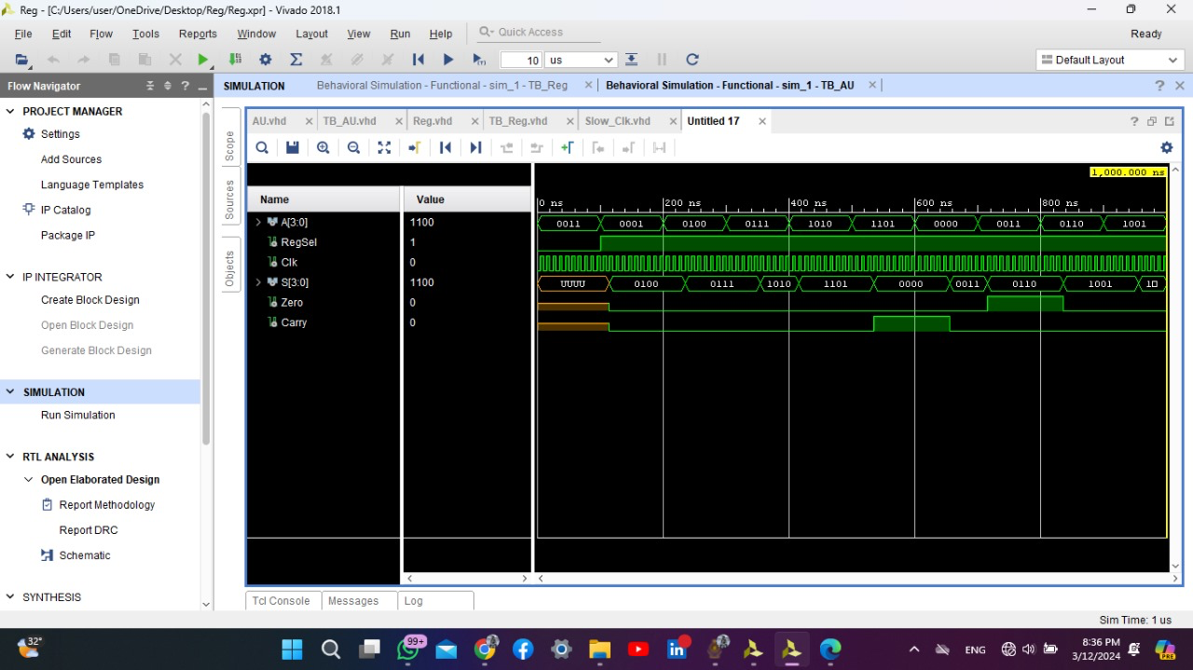**Timing Diagram**

**Implemented design schematic**

**Constraints File**

## Clock signal

set_property PACKAGE_PIN W5 [get_ports Clk]

set_property IOSTANDARD LVCMOS33 [get_ports Clk]

create_clock -add -name sys_clk_pin -period 10.00 -waveform {0 5} [get_ports Clk]

## Switches

set_property PACKAGE_PIN V17 [get_ports {A[0]}]

set_property IOSTANDARD LVCMOS33 [get_ports {A[0]}]

set_property PACKAGE_PIN V16 [get_ports {A[1]}]

set_property IOSTANDARD LVCMOS33 [get_ports {A[1]}]

set_property PACKAGE_PIN W16 [get_ports {A[2]}]

set_property IOSTANDARD LVCMOS33 [get_ports {A[2]}]

set_property PACKAGE_PIN W17 [get_ports {A[3]}]

set_property IOSTANDARD LVCMOS33 [get_ports {A[3]}]

set_property PACKAGE_PIN R2 [get_ports {RegSel}]

set_property IOSTANDARD LVCMOS33 [get_ports {RegSel}]

## LEDs

set_property PACKAGE_PIN U16 [get_ports {S[0]}]

set_property IOSTANDARD LVCMOS33 [get_ports {S[0]}]

set_property PACKAGE_PIN E19 [get_ports {S[1]}]

set_property IOSTANDARD LVCMOS33 [get_ports {S[1]}]

set_property PACKAGE_PIN U19 [get_ports {S[2]}]

set_property IOSTANDARD LVCMOS33 [get_ports {S[2]}]

set_property PACKAGE_PIN V19 [get_ports {S[3]}]

set_property IOSTANDARD LVCMOS33 [get_ports {S[3]}]

set_property PACKAGE_PIN P1 [get_ports {Carry}]

set_property IOSTANDARD LVCMOS33 [get_ports {Carry}]

set_property PACKAGE_PIN L1 [get_ports {Zero}]

set_property IOSTANDARD LVCMOS33 [get_ports {Zero}]

**Conclusion**

In conclusion, the 4-bit Arithmetic Unit (AU) crafted in this lab serves as a digital powerhouse capable of adding numbers stored in distinct registers. Similar to a counter's versatility, this AU exhibits flexibility by accommodating two registers, enabling users to input 4-bit binary values via switches. Functionality is orchestrated through clock synchronization, and the outcome of the addition process is vividly displayed on LEDs. Much like a counter measuring occurrences, this AU extends its utility to compute and showcase the sum of registered numbers, underscoring its significance in diverse electronic applications. The seamless integration of theoretical concepts with practical implementation in this lab not only enhances our understanding of digital design but also equips us with valuable skills for future endeavors in microprocessor architecture.

-End-